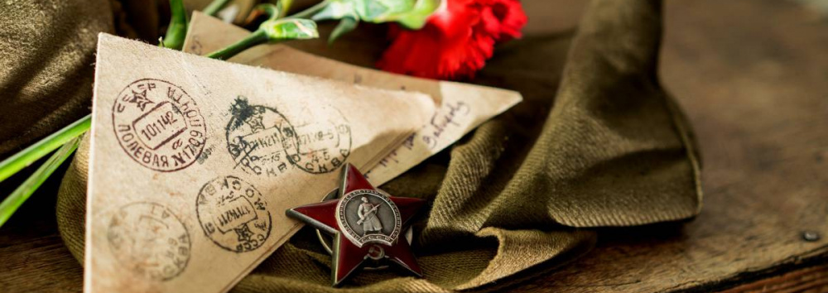
ПИСЬМО СОЛДАТУ ПОБЕДЫ

______________________________________________________________________________________________

_____________________________________________________________________________________________

_____________________________________________________________________________________________

_____________________________________________________________________________________________

_____________________________________________________________________________________________

_____________________________________________________________________________________________

_____________________________________________________________________________________________

_____________________________________________________________________________________________

_____________________________________________________________________________________________

____________________________________________________________________________________________

____________________________________________________________________________________________

____________________________________________________________________________________________

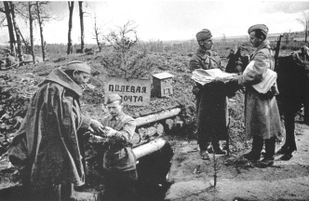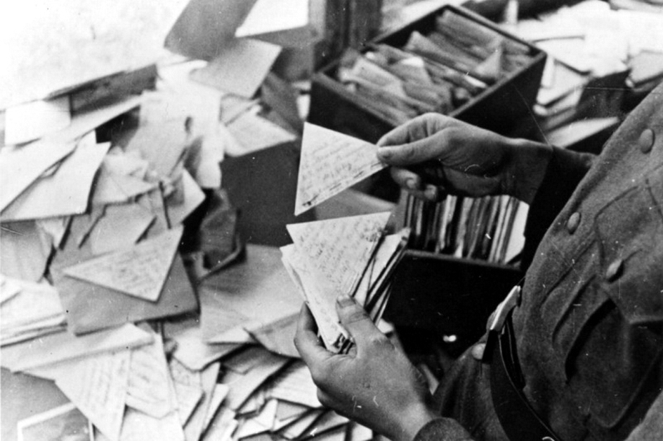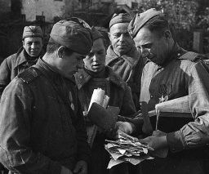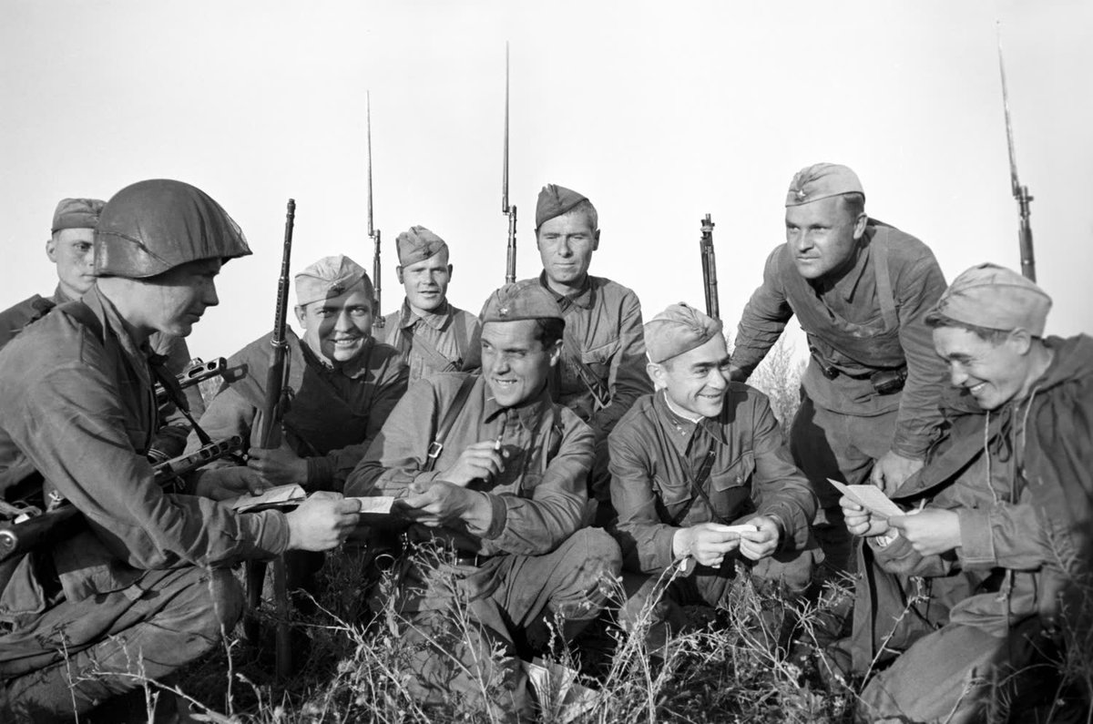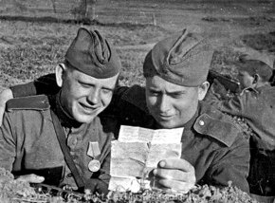

2020

